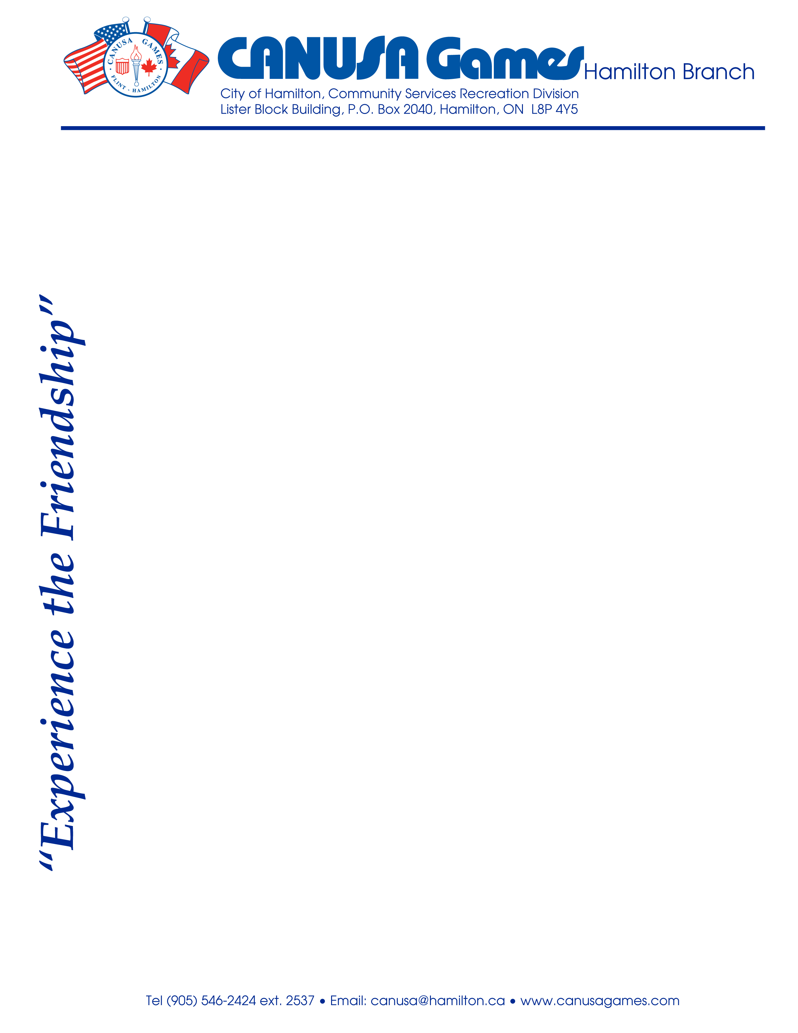

VOLUNTEER APPLICANT REQUEST FOR VULNERABLE SECTOR SCREENING

Volunteer Name: ________________________

To Whom It May Concern:

The above-mentioned volunteer has applied to the CANUSA Games in Hamilton.
The CANUSA Games is a not-for-profit organization that is the largest and longest-running amateur international games in North America.
CANUSA holds Olympic-style sporting competitions for children between the ages of 8 to 18, alternating annually between the cities of Hamilton, Ontario, Canada and Flint, Michigan, USA.
As part of the organization’s screening process, volunteers are required to complete the REQUEST FOR VULNERABLE SECTOR SCREENING, a copy of which has been provided to this volunteer applicant.

The volunteer is aware that a charge is applicable and is the responsibility of the volunteer.

Thank you for your support of the CANUSA Games.

Sincerely,
Alex Buck
CANUSA Games Board of Directors,
Police Liaison

